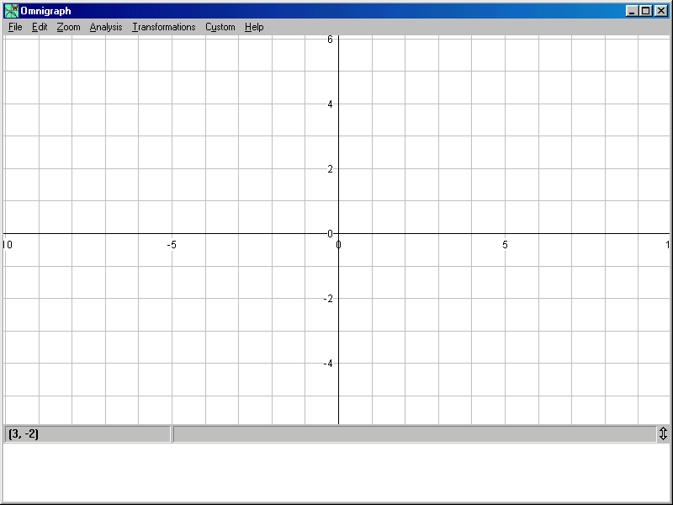

THE EQUATION OF A STRAIGHT LINE SIDE 2
FIND THE EQUATION OF EACH STRAIGHT LINE IN TERMS OF Y = MX + C

